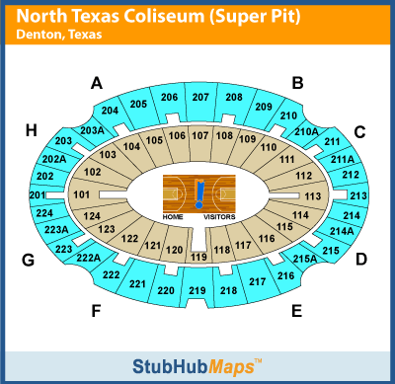

 **Rows 1-15 of Section 120 Reserved for BNHS Staff**

 **Indicates Entrances for Guests**

C:\Documents and Settings\EMiller01\Local Settings\Temporary Internet Files\Content.IE5\ADWZLYVV\MC900329243[1].wmf

Graduates will exit here.